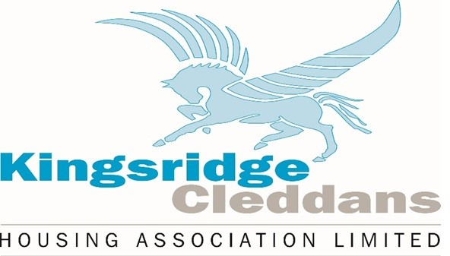

Complaints

Our Commitment to You
Kingsridge Cleddans Housing Association is committed to providing high-quality service. We value your feedback and take complaints seriously. If something has gone wrong, or you feel unhappy about something we want to know so we can put it right and improve our services.
What Is a Complaint?
A complaint is when you tell us you are unhappy with:
- A service we have provided
- Delays on responding to enquiries, requests or call backs etc
- Treatment by or attitude of a member of staff
- How a decision has been made

You can complain yourself, or someone can do it on your behalf (with your permission).

When making a complaint, please tell us:

- What happened
- When did it happen
- How it has affected you
- What you would like us to do to put things right

When we receive a complaint, we will:

- Listen to what you have to say
- Carry out a thorough and fair investigation
- Try to resolve the complaint, there and then where possible
- Apologise and look to take action to ensure that it doesn’t happen again.

How to Make a Complaint:
You can make a complaint several different ways.
- In person – Speak to a member of staff in the office
- By phone – Call in to our office
- In writing – Letter or email
- Online – Via website complaint form

If You Are Still Unhappy:
If you remain dissatisfied after completing our complaints process, you may be able to contact an independent body such as:
- The Scottish Public Services Ombudsman (SPSO)
We will provide you with full details if this stage is reached.

Contact Us:
Kingsridge Cleddans Housing Association
📍 Office Address: Units 2/3 Ladyloan place, Drumchapel G15 8LB
📞 Telephone: 0141 944 3881
📧 Email: admin@kc-ha.com

