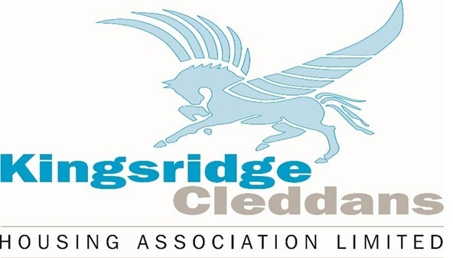

KCHA Office will be closed on Friday 18th April and Monday 21st April.

