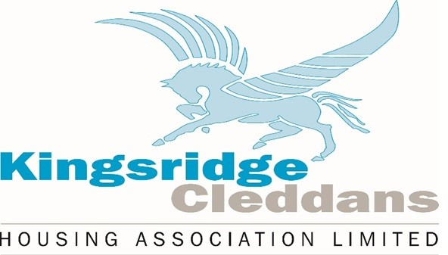

Name of Policy | Relet Standards
Responsible Officer | Asset Management Officer
Date approved by Board | 24 February 2023
Date of next Review | February 2026
Section | Asset management

Contents.

Section |  | Page
1. | Introduction | 3
2. | Standard | 3
3. | Fixtures and Fittings | 3
4. | Electrical | 3
5. | Central heating | 4
6. | Sanitary Ware and Plumbing | 4
7. | Windows | 4
8. | Cleanliness and Decoration | 4
9. | Gardens | 4
10. | Asbestos | 4
11. | Damp and mould | 5
12. | Policy Review | 5
13. | Equality and Diversity | 5

- INTRODUCTION

The purpose of this policy is to define and apply minimum standards that will be used when assessing and instructing void repair work prior to a property being relet.

STANDARD

The property shall be in a good habitable condition prior to being relet. The
Association may from time to time vary standards of repair within void properties, but a minimum standard is required and in particular:

“All components of the property shall be in good working order and free from defect. The property will also be wind and watertight”.

And the property will be free of any substantial damp and mould.

Minimum standards require clarification and definition and can be defined as follows.

FIXTURES AND FITTINGS

Kitchen units: Kitchen units will be in working order and in a satisfactory condition. Doors and drawers will be able to open and close. All handles will be in place.

Internal doors: All internal doors will be in place and intact with no damage. Doors will be able to open and close freely and all ironmongery will be in place and in working order. Fire doors must be able to self- close.

Skirting/facings/checks: All skirting, facings, checks will be in place and any missing sections replaced.

Front/rear doors: Front/rear doors will be able to open/close freely with handles and hinges intact. Two sets of keys will be available for doors. Locks will be in working order.

Stair-posts, Handrails and Newel Posts: Will all be intact and secure.

ELECTRICAL

- Sockets, light switches, and light fittings/pendants will all be intact, and any damaged items replaced.
- Smoke alarms will be checked to ensure they are in working order
- A full electrical check will be carried out at the void property stage before the new tenant moves in.
- Kitchen and bathroom extractor fans will be in working order and functional.

CENTRAL HEATING

- The central heating system and boiler will be in full working order.
- a gas boiler safety check will be carried out at the void property stage.
- a copy of the landlord gas safety certificate will be given to the new tenant.
- If the system has not been serviced in the previous 12 months this will be carried out at the void stage.
- Radiators will be secured to the wall and free of leaks.

SANITARY WARE & PLUMBING

Baths, wash hand basins, sinks and w.c. bowls will be able to hold water and be free of leaks. Taps will be functional and free of drips. All pipes and installation will be free of leaks.

WINDOWS

All glazing will be intact, and windows will be able to open freely. If windows are lockable, keys will be provided. Handles will be intact and functional, and frames will be free of rot. Trickle vents will be functional. Safety mechanism will be operational.

CLEANLINESS AND DECORATION

The Association is not responsible for the decoration order of the property. However, where standards are so poor that reletting is difficult, minimum decoration will be carried out. This will be authorised by the Asset Management Officer.

The property will also be clear of any household goods or furniture before being presented for viewing. A valet service will be carried out where standard of cleanliness is unacceptable.

GARDENS

Gardens will have clothes drying facilities in the form of rotary dryers or clothes poles. All fencing will be intact and where gardens have gates these will be able to open and close freely. If garden ground is overgrown, then the Association will carry out a first cut in the growing season.

- ASBESTOS

An asbestos survey was instructed for any property that was constructed prior to 2000, in accordance with our Control of Asbestos at Work Regulations 2002 Policy Statement. The survey details were entered into our Asbestos Register. To date, no asbestos has been found in any of our properties.

In the unlikely event that asbestos is discovered, it will be removed by an accredited Asbestos Removal contractor who will provide a report confirming that the property can be safely relet.

- DAMP AND MOULD

All properties will be free of substantial damp and mould.
Where any is apparent in a void property this will be treated and the cause shall be determined to endeavour to ensure that this issue does not return.

- POLICY REVIEW

This policy will be reviewed in line with our policy review schedule or earlier should the need arise.

- EQUALITY AND DIVERSITY

As a service provider and employer, we recognise the requirements of the Equality Act 2010, oppose any form of discrimination and will treat all customers, internal and external, with dignity and respect. We recognise diversity and will ensure that all our actions ensure accessibility and reduce barriers to employment and the services we provide.

