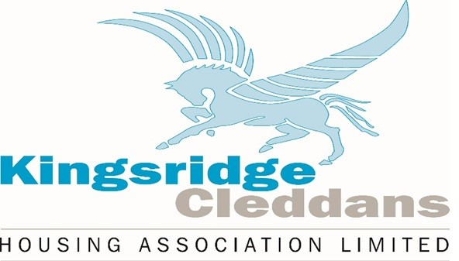

Name of Policy | Rent Setting
Responsible Officer | Director
Date approved by Board | 24 February 2023
Date of next Review | February 2026
Section | Corporate Services

Contents.

Section |  | Page
1. | Introduction | 3
2. | Aims and Objectives | 3
3. | Rent Levels and Affordability | 3
4. | Mainstream Rent Setting method | 3
5. | Shared Ownership | 4
6. | Supported Accommodation | 4
7. | Comparability | 4
8. | Annual Rent Review | 4
9. | Policy Review | 5
10. | Equality and Diversity | 5

- Introduction

Kingsridge Cleddans Housing Association is required by the Scottish Housing Regulator to formulate a rent setting policy, which will allow the Association to set affordable rents for all our housing stock.

In adopting this policy, the Association should ensure that the rental income will cover running costs and be comparable with other rents in the area.

- Aims and objectives

The Association's aim is to set rents based on a rental policy, which is both easy to administer and easily understood by staff, committee and our customers.

The Association is also committed to ensuring that rent levels remain competitive with those of other social landlords and are affordable to tenants.

While taking the above factors into account, the Association must ensure that rent levels provide sufficient funding for:

- Management and Maintenance costs.
- Future repairs, including major repairs.
- Investment in our properties.
- Voids and bad debt provision.
- Inflationary indicators.
- Meeting our duties to the Council to help alleviate homelessness through developing.

- Rent levels and affordability

Affordability is subjective and can be influenced by spending patterns, lifestyle choices and other household debts. We will measure affordability through the use of comparison benchmarks with other housing providers, particularly those within the social housing sector. We will also measure our rents against rent affordability tools as provided by organisations such as SFHA. Finally, we will seek feedback from tenants on how they feel their rent is affordable and offering value for money.

- Mainstream rent setting method

Mainstream rent charges are based solely on size of accommodation. The Association has 279 mainstream rental properties, 11 shared ownership properties and 2 supported accommodation properties.

Service charges for the mainstream properties are charged in reflection of the services provided to the properties.

- Shared ownership – occupancy charge

The Association has 11 shared ownership properties. The sharing owners have an Exclusive Occupancy Agreement and as such the method of increasing any element of the charge is different to that of the mainstream rented properties.

There are 4 elements to the Occupancy Charge, being base rent, building insurance, gas service/maintenance and management fee.

The base rent element will be increased in line with the proposed mainstream rent charge annually and the service charges will increase in line with the actual costs of the provision of the service.

The sharing owners will be sent an Occupancy Charge Notification (OCN) detailing the new charges to be applied from the 1st April each year. The OCN will be sent no later than 28 days prior to the charge taking effect.

- Supported accommodation

The Association has 2 supported accommodation properties each housing 3 service users, giving a total of 6 service users. There are two distinct charges applicable to the service being the core rent element and the service elements.

As with above, the core rent element will be increased in line with the mainstream rent increase annually from the 1st of April. The service elements will be increased in line with the actual cost of providing that service.

New charges will be notified in writing to the residents/the residents advocate/care provider no later than 28 days prior to the new charge being applied.

- Comparability

The Association's rent levels for each property type will be compared against those within the sector and information on our rents will be reported to the Management Committee and shall also be detailed in our annual report to tenants.

- Annual rent review

A review of the rents and service charges will be carried out annually.
The Management Committee will consider the budget for the coming year, as well as investment plans as set out in the 5 and 30 year plan. They shall also consider any perceived increase in costs in running the Association, other than those as set in the budget, which may impact the long-term financial viability of the Association. After considering the financial needs of the Association, the Management Committee will consider if the rents require to be reviewed. If they consider a rent increase to be necessary, they will look, in accordance with the tenancy agreement, to carry out a consultation process. Once this is completed, the Management Committee will again look to discuss the proposed increase and shall agree and finalise any change.

Any increase will be applied from 1st April. All tenants and residents will be advised of any alteration to the rent and/or service charges in writing at least 28 days in advance of the new charge taking effect on 1st April.

- Policy review

The Policy will be reviewed in line with our policy review schedule.

10. Equality and Diversity

As a service provider and employer, we recognise the requirements of the Equality Act 2010, oppose any form of discrimination and will treat all customers, internal and external, with dignity and respect. We recognise diversity and will ensure that all our actions ensure accessibility and reduce barriers to employment and the services we provide.

