APPROVED/ADOPTED | 28 March 2023
Date of Next Review | March 2026
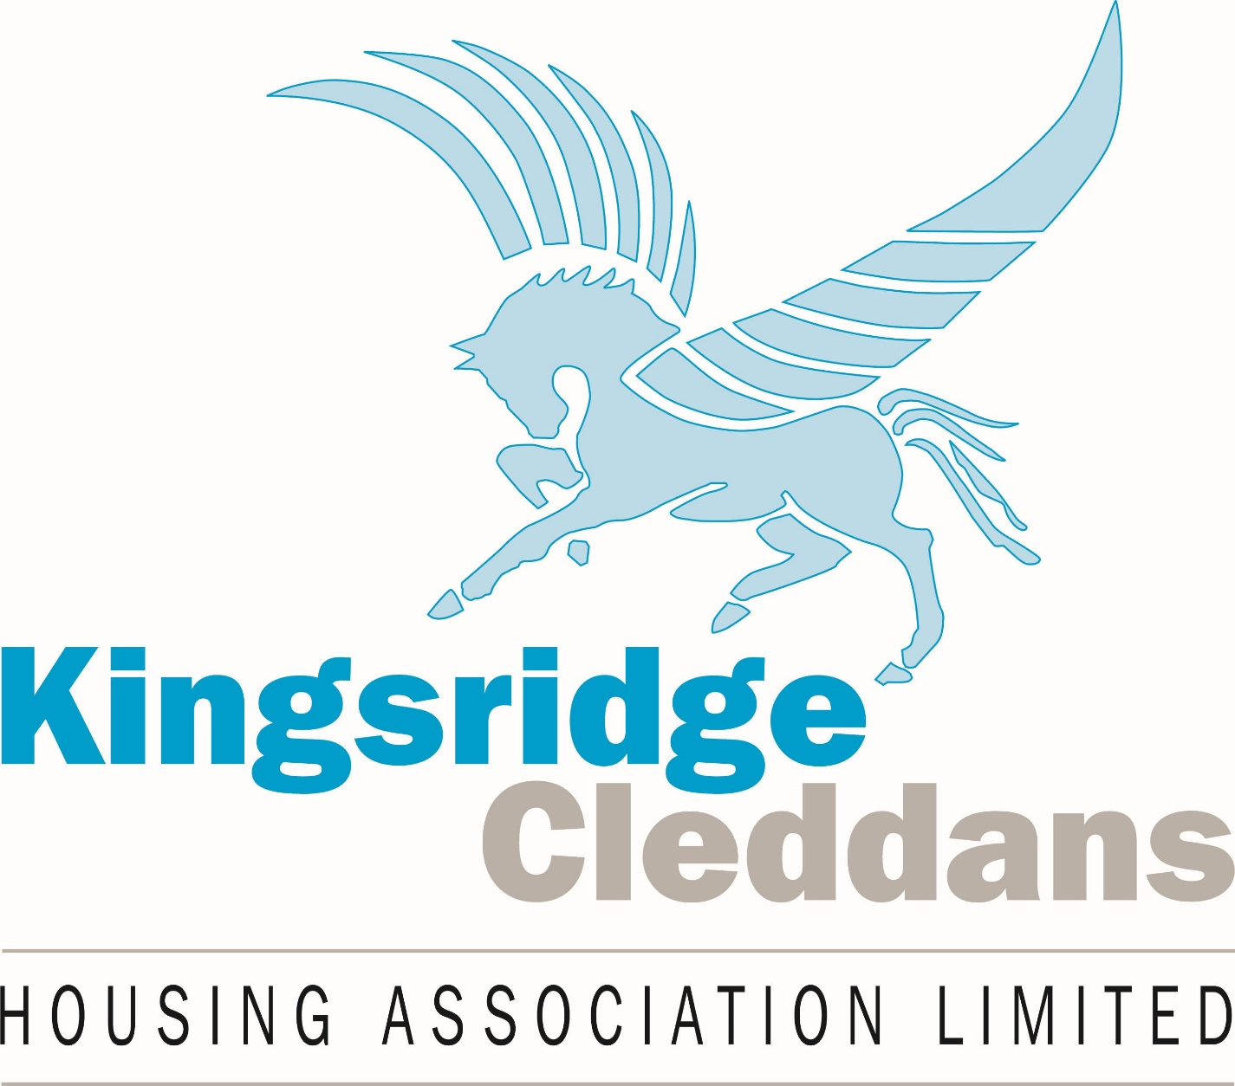
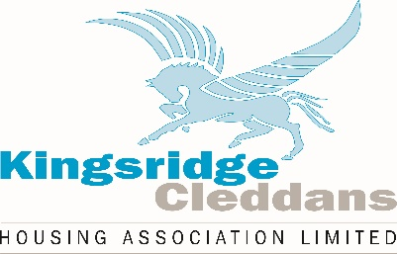

MODEL POLICY
SETTLEMENT AGREEMENTS

1.0 INTRODUCTION

1.1 Kingsridge Cleddans Housing Association Ltd. expects that its existing range of employment policies will be able to successfully resolve the huge majority of workplace disputes, and business challenges we may face. However, we also acknowledge that there may be occasions when “Settlement Agreements” can be considered when unique situations, that our policies do not directly provide for, arise.

1.2 Our aim is to resolve disputes sensibly and thus minimise the use of Settlement Agreements. Where they are used, we will ensure that conditions contained within them are restricted to those necessary to deal with the industrial relations, business challenge and employment law issues concerned. We will also seek value for money in any agreement(s) we conclude.

2.0 BACKGROUND

2.1 Settlement Agreements (formerly known as Compromise Agreements) are one way in which employers and employees (or former employees) mutually agree to deal with local disputes and business challenge issues that may otherwise have had potential to reach an Employment Tribunal (or other court).

2.2 Settlement Agreements will often be used to bring the employment relationship to an end in a conclusive and binding manner. However, they can also be used to deal with other types of workplace issue we may have from time to time, such as: changes to working patterns; disputes over overtime arrangements; introduction of new grading systems and similar.

2.3 We would expect our existing policies: such as Redundancy, Retirement, Grievance, Discipline, Company Sick Pay, Notice Provisions and similar; along with, our local/national negotiating framework(s) - to provide methods to deal with the majority of such matters.

2.4 However, without implying any sense of entitlement, we do nonetheless reserve the right to resolve employment disputes using Settlement Agreements where we consider it sensible to do so. For example, we may include our using these as a further safeguard in redundancy situations. We may also consider their use where the employment relationship with one of our employees has irretrievably broken down; or, where it has broken down between employees – and where none of our existing policies offer an obvious method to resolve the problem.

2.5 We accept that in all cases any agreement struck must be entered into voluntarily by the employee(s), and that they must also have received suitable advice from an appropriately qualified and indemnified person.

3.0 CONTENTS OF ANY AGREEMENT

3.1 Disputes in which employees are remaining in our employment may be settled with a variety of monetary and/or other provisions as are pertinent to the matters at hand – overtime pay rates may be altered; small monetary sums may be agreed to effect a change in working practices; changes to shift working patterns may be agreed, and such like.

3.2 Where a dispute results in the employee leaving our employment (or a similar issue with a former employee resulting in their waiving any rights to approach an employment tribunal) the main tool in settling the matter will generally be to pay an agreed financial sum to the employee. In this regard we will always aim to keep such payments reasonably low (albeit keeping in mind the depth and complexity of the particular dispute).

3.3 In no circumstances will the total value of any payment exceed the upper limit achievable (weeks’ pay basis) within our local arrangements on redundancy pay. That amount aside, we also acknowledge the additional need to pay contractual elements as may be due, such as notice pay and outstanding holiday pay. Any agreement we strike will separate the various payments and will clearly identify those elements (and their value) which will be subject to income tax and national insurance contributions in the normal way.

3.4 From time to time, and in the light of particular circumstances faced, we may consider including other “one-off” components within an agreement. For example, me may waive our right to reclaim training costs made on behalf of the employee concerned; or, come to an arrangement over the employee not having to return company property or vehicles we had provided. This list is not exhaustive but, in all cases, the realistic value of such items will be taken into account (and form a part of) the overall limits we have set out above.

3.5 We will also offer a factual reference where asked to do so. Such reference will state the start and end dates of employment with us; the post title; the range of duties included within the post; and, the applicable salary range. Our reference will not allude to the level of performance, nor the reason the employment came to an end.

3.6 We will also include the expected provisions confirming that both parties will maintain suitable confidentiality in relation to the terms of the agreement and the requirement not to disclose these. However, we will restrict such provisions to cover those matters that are normally confidential within an industrial relations framework; or those that are otherwise specifically contained within the spirit of the General Data Protection Regulations framework. We will not include restrictions on disclosing matters beyond – particularly such issues that are undeniably of wider public interest/whistleblowing.

4.0 CONCLUDING AGREEMENTS

4.1 We acknowledge that no agreement may be struck unless the employee(s) concerned have received advice from a suitably qualified and indemnified adviser – such as an authorised/certified trade union person; an authorised/certified advice worker; or a lawyer. We will not permit the employee to use any adviser who is also acting for us. Where the adviser charges the employee a fee, we will cover that cost up to the value of £250 plus VAT. Where the fee is higher than this, then the employee will be responsible for paying the balance. Such sum as we pay in this regard will be over and above the overall limits we have earlier set out.

4.2 From our side we may use any resource* whom we feel is best able to conclude the agreement on our behalf, for example our EVH HR team; an external HR service, an ACAS official, or an employment lawyer. We may also mix and match – for example our EVH HR people may deal with the difficult “negotiations” stage before passing the matter onto another adviser/ACAS official/lawyer to write up the formal agreement paperwork.

Kingsridge Cleddans Housing Association may be compelled to take formal “legal” advice prior to concluding a Settlement Agreement.

5.0 COSTS INVOLVED

5.1 Aside from the value of any payments made to employees, we will seek value for money in the cost involved in our executing any agreement. Wherever possible we will have our EVH HR people* perform all required work. If we do not have internal capacity we will seek support from other external HR advisers, or from our lawyers. Where the matter has reached ACAS Pre-Employment Tribunal conciliation, we will use the (free) ACAS service in concluding any agreement – unless we feel that the matters are so complex as to warrant our substituting our own agreement paperwork (bearing in mind that this may undo any good will built up with the employee/ACAS officials in getting to a “yes” position).

Kingsridge Cleddans Housing Association may be compelled to take formal “legal” advice prior to concluding a Settlement Agreement.

5.2 Due to the expected limited use, we will sense check likely costs involved each time we execute a Settlement Agreement. We are aware that EVH, and others, may be able to offer information on what a variety of advisers typically charge.

6.0 EQUALITIES IMPACT

6.1 We do not see this policy as having any direct impact upon the protected characteristics contained within the Equality Act 2010. We will however be mindful in the way we select those unresolved disputes/business challenge issues to route via the Settlement Agreement method.

6.2 We will also be mindful of the way in which we present this option to employees and the language we use when discussing any proposition with them. By extension we will avoid holding any assumptions as may be viewed to be discriminatory, and/or taking actions which in themselves could be perceived as victimising the employee(s) concerned.

6.3 We will also take account of the advice contained within the EVH “Pre-termination Discussions & Settlement Agreements” Information Note (February 2023); along with the information contained within the relevant ACAS Code of Practice.

